

**PUSL3190 Computing Individual Project**

**Final Report**

**Smart Voting System using Face Detection and Recognition Application**

**Supervisor: Ms. K Rajapaksha**

Name: Jayasekara Jayasekara

Plymouth Index Number: 10899567

Degree Program: Software Engineer

Contents

Acknowledgement 3

Abstract 4

1. Introduction 6

2. Background 7

2.1 Key Technologies and Measurements 8

Facial Recognition Technology 8

Real-time Data Processing 8

Database Management and Security 8

Usability and User Experience (UX) 9

Accuracy and Error Metrics 9

3. Objectives 9

3.1 Development of a secure facial recognition login system 9

3.2 Create a user-friendly voting platform 9

3.3 Ensure data security and privacy 10

3.4 Enable efficient election management 10

3.5 Promote transparency and fairness 10

3.6 Develop an affordable and scalable solution 10

4. Deliverables 11

4.1 Web Application 11

4.2 Programming Languages ​​and Tools 12

4.2.1 Front-end 12

4.2.2 Backend 12

4.3 Summary of key features 12

5. Literature Review 13

5.1 Existing Systems in Electronic Voting and Sustainability Management 13

5.2 Shortcomings of Existing Systems 14

5.3 Identified Gaps 14

5.4 Addressing Gaps 14

6. Method of Approach 15

6.1 Functionalities 15

6.2 Technologies Used 15

6.3 Data Collection 15

6.4 Testing 16

6.5 Development Methodology 16

7. Requirements Specification 17

7.1 Functional Requirements 17

7.2 Non-functional requirements 18

7.3.1 Voter End Requirements 18

7.3.2 Server End Requirements 19

7.3.3 Administrative End Requirements 20

7.3.4 Additional Hardware (Optional) 20

8.User Interfaces 20

8.1. Admin Registration and Login Pages 20

8.2. Admin Dashboard 21

8.3. Voter Registration 22

8.4. Election Start page 22

8.5. Candidate Manage page Edit and Deleted 23

8.6 Election Result 23

8.7. Users Dashboard 24

8.8. Map Location 24

Introduction 27

Background 27

Relevance 28

Business case 29

2.1 Business needs 29

Security issues: 29

2.2 Supporting evidence 30

2.3 Business objectives 30

Specific business objectives include: 30

Project objectives 31

3.1 SMART objectives 31

Literature review 33

4.1 Related work 33

Approach method 35

5.1 Methodology 35

Tools and technology 36

High-level architectural diagram 37

Basic project plan 38

6.1 Timeline 38

6.2 Gantt chart 40

Roles and Responsibilities 40

Roles and responsibilities 41

Risk analysis 42

7.1 Identified risks 42

Stakeholder analysis 43

8.1 Key stakeholders 43

1. Key stakeholders: 43

2. Secondary Stakeholders: 43

3.External stakeholders: 44

Stakeholder expectations and management 45

Communication Plan 45

9.1 Privacy and Data Protection 45

9.2 Security and Confidentiality 45

9.3 Fairness and Non-Discrimination 46

9.4 Transparency and Accountability 46

9.5 Ethical Use of Technology 47

References 48

Chapter 01: Introduction 51

1.1 Introduction 51

1.2 Problem Definition 51

1.3 Project Objectives 51

Chapter 02: System Analysis 52

2.1 Data Collection Techniques 52

2.2 Existing System 53

2.4 Shortcomings of the Current System 54

Chapter 03: Requirements Specification 55

3.1 Functional Requirements 55

3.2 Non-functional requirements 56

3.3 Hardware / Software Requirements 56

3.4 Networking Requirements (Optional) 57

Chapter 04: Feasibility Study 57

4.1 Operational Feasibility 57

4.2 Technical Feasibility 58

4.3 Outline Budget 59

Chapter 05: System Architecture 60

5.1 Class Diagram of the Proposed System 60

5.2 ER Diagram 61

5.3 High-level Architectural Diagram 63

5.4 Networking Diagram 63

Chapter 06: Development Tools and Technologies 64

6.1 Development Methodology 64

Programming Languages ​​and Tools 64

Third-party components and libraries 65

6.4 Algorithms 65

Chapter 07: Discussion 66

7.1 Overview of the Interim Report 66

7.2 Report Summary 66

7.3 Challenges Faced 66

7.4 Future Plans / Upcoming Work 67

Appendices (if applicable) 68

Kjaggjal

Kajjba

# Acknowledgement

I would like to express my sincere gratitude to all those who supported and guided me throughout the successful completion of my final year project, a facial recognition voting system for university elections. First and foremost, I am grateful to my supervisor for his invaluable guidance, continuous support, and insightful feedback at every stage of the project. Their encouragement and expertise have been crucial in shaping the project and overcoming challenges along the way.

I am also grateful to the university administration and faculty members who provided the necessary resources and feedback to ensure the practical relevance of the project. Their understanding of voting processes and university election systems has been essential in designing a solution that meets real-world needs. Special thanks to all those who participated in testing the system, providing valuable feedback that helped refine the final product. I would like to express my heartfelt gratitude to my family and friends for their unwavering support, motivation, and understanding throughout this journey. Their encouragement played a vital role in keeping me focused and determined.

Finally, I am deeply grateful to everyone who contributed to the success of this project. Your support was invaluable, and I look forward to applying the lessons learned in future endeavors.

# Abstract

This project focuses on developing a web-based facial recognition voting system designed specifically for university elections. Recognizing the need for enhanced security, transparency, and efficiency in voting, this system leverages facial recognition technology to verify voter identities accurately and prevent fraudulent voting. The platform streamlines the election process by allowing students to log in with their university ID, authenticate their identity through a live webcam face scan, and cast their votes securely. Key features include real-time voter verification, one-time voting enforcement, candidate management, and automated result tallying.

The system also offers a user-friendly interface that simplifies the voting experience while maintaining a high level of security and data privacy. Informed by feedback from students and university election committees, this project aims to modernize traditional voting methods, reduce manual errors, and promote greater student participation. By integrating cutting-edge technology with the practical needs of university elections, the system sets a foundation for future improvements in digital voting solutions.

# 1. Introduction

University elections are an important part of student governance, allowing students to choose leaders who represent their voices and interests. However, traditional election methods often face challenges related to security, efficiency, and authenticity. Manual verification of voter identity, the use of physical ballots, and administrative delays can lead to problems such as voter impersonation, vote counting errors, and lack of transparency.

With the advancement of technology, facial recognition has emerged as a powerful tool for identity verification. Facial recognition systems use biometric data to accurately verify individuals, providing a secure and efficient alternative to traditional voting methods. Recognizing these benefits, this project introduces a web-based platform that integrates facial recognition technology to modernize the voting process for university elections.

Security and trust are crucial when it comes to elections. By ensuring that only registered voters can vote – and that each person can only vote once – the system significantly reduces the risk of fraudulent voting and impersonation. This initiative aligns with the broader goal of digital transformation in educational institutions, and aims to provide voters and administrators with a transparent, user-friendly, and secure election experience.

While there are modern e-voting systems available commercially, they often come at a high cost and require extensive technical expertise to deploy and manage. Many universities, especially in developing regions, find these solutions inaccessible due to budget constraints and complexity. Therefore, this project focuses on developing an affordable, customizable, and easy-to-use facial recognition voting platform tailored specifically for university environments.

This project aims not only to introduce a technical solution, but also to investigate the challenges and best practices in implementing biometric voting systems. By addressing security, usability, and accessibility issues, the proposed system seeks to promote fair, efficient, and transparent university elections using modern technology.

# 2. Background

The concept of electronic voting (e-voting) has evolved significantly over the past few decades as institutions seek more efficient, secure, and transparent methods for managing elections. Traditional paper-based voting methods, while widely used, are often associated with issues such as voter fraud, ballot tampering, human error, and long processing times. In response to these issues, many countries and organizations have explored the use of electronic voting machines and online voting platforms. However, the challenge of ensuring that the person casting the vote is the authorized voter remains a critical issue.

Facial recognition technology offers a powerful solution to this challenge. It provides a non-invasive, fast, and accurate way to verify a voter’s identity based on their unique facial features. Unlike passwords, ID cards, or fingerprint scans, facial recognition does not require physical contact or additional equipment, making it a convenient option for both administrators and users.

In the context of university elections, the use of facial recognition can face multiple challenges. Student populations are often dynamic, and manually verifying student identities can be time-consuming and error prone. Moreover, as universities strive to promote technological literacy and innovation among students, introducing a biometric voting system makes both practical and educational sense.

Several commercial facial recognition voting solutions are available, but their high cost and complexity make them less suitable for universities with limited budgets and resources. In addition, privacy, data security, and system reliability issues must be carefully considered when implementing biometric systems.

This project aims to design and develop a low-cost, secure, and user-friendly facial recognition voting platform suitable for university environments. The system will integrate real-time facial recognition and matching processes to verify voter identity before allowing voting. It ensures that all voting data is securely stored and protected and complies with privacy standards and ethical considerations.

By leveraging facial recognition technology, the project addresses the need for safe, efficient, and transparent elections while promoting technological advancements and trust within the university community.

### 2.1 Key Technologies and Measurements

When developing a secure and efficient facial recognition voting system for university elections, several key technologies and measurements are critical to ensuring the functionality, accuracy, and reliability of the system. These elements form the foundation of the project and guide its technical and operational direction.

### Facial Recognition Technology

The core of the system is facial recognition technology, which uses advanced algorithms to identify and authenticate individual faces. This technology captures facial images via a webcam or camera, analyzes key facial landmarks, and compares them with pre-registered templates securely stored in a database. The accuracy of the facial recognition algorithm is critical in preventing identity fraud and ensuring that only authorized students are allowed to vote.

Key Features of Facial Recognition:

* Face Recognition: Identifying and locating a human face in an image or video frame.
* Face Alignment: Normalizing the orientation of the detected face to improve recognition accuracy.
* Feature Extraction: Mapping key facial features such as eyes, nose, and mouth to create a unique facial description.
* Face Matching: Comparing the live captured facial descriptor with stored templates to verify identity.

### Real-time Data Processing

Real-time processing capabilities ensure a smooth voting experience. The system quickly captures, analyzes, and verifies facial data, allowing users to complete the voting process with minimal latency. Speed ​​and responsiveness are critical metrics, especially in settings with a large number of users.

### Database Management and Security

All voter profiles, including their facial templates and voting records, are securely stored in a cloud-based database such as Firebase. Ensuring the integrity, confidentiality, and availability of this data is a top priority. Encryption techniques and secure authentication methods are used to protect sensitive voter information.

Database security measures include:

* Data encryption at rest and in transit
* Role-based access control
* Regular backups and redundancy
* Compliance with data protection regulations

### Usability and User Experience (UX)

Since the system is intended to be used by university students of various technical backgrounds, it should provide a simple, intuitive interface. A user-friendly design minimizes the learning curve and improves participation rates. Metrics such as error rates at login, time to vote, and user satisfaction surveys are used to evaluate UX success.

### Accuracy and Error Metrics

* The performance of the system is evaluated through several key accuracy metrics:
* False Acceptance Rate (FAR): The probability that the system incorrectly matches an input face to a template that does not match.
* False Rejection Rate (FRR): The probability that the system fails to correctly identify a face that matches.
* Recognition Accuracy: The overall percentage of users who were correctly authenticated.
* System Uptime: The percentage of time the system is up and running during the election process.

Balancing these metrics is essential to providing a reliable and trustworthy voting experience.

# 3. Objectives

The primary objective of this project is to design and develop a web-based facial recognition voting system specifically tailored for university elections. The aim of this system is to provide a more secure, efficient and modern solution that improves the integrity and convenience of the voting process instead of traditional voting systems.

The main objectives of the project are as follows:

## 3.1 Development of a secure facial recognition login system

* To implement a reliable facial recognition mechanism to authenticate voters using their university ID cards and real-time webcam images.
* Ensure that each student can vote only once by linking facial recognition data to a single-use voting session.
* Prevent unauthorized access and voter fraud through accurate biometric authentication.

# 3.2 Create a user-friendly voting platform

* Create intuitive interfaces for all users (voters, administrators, and election officials).
* Simplify the voting process so that students can easily verify their identity, view candidate profiles, and cast their ballots in a few simple steps.
* Provide clear guidance and support within the platform to minimize user confusion or errors.

## 3.3 Ensure data security and privacy

* Securely store facial recognition data, personal information, and voting records in an encrypted database.
* Comply with applicable data protection standards to maintain voter confidentiality and trust.
* Implement strong back-end security, including role-based access controls and secure data transmission protocols.

## 3.4 Enable efficient election management

* Provide administrative tools to manage candidate registrations, track election progress, and view election results.
* Provide real-time access to election statistics such as voter turnout and the votes received by a candidate.
* Generate detailed election reports for transparency and record-keeping.

## 3.5 Promote transparency and fairness

* Ensure the system is free from bias by using unbiased training datasets and optimizing facial recognition algorithms.
* Allow for independent audits of system operations to verify fairness and accuracy.
* Provide traceability features to allow election authorities to investigate any disputes or anomalies.

## 3.6 Develop an affordable and scalable solution

* Use open source technologies and cloud services to keep development and operational costs low.
* Design the system so that it can be scaled to accommodate larger elections in the future or be used by multiple faculties or universities.

# 4. Deliverables

This project will create a fully functional web-based facial recognition voting system designed for university elections. The following deliverables will be provided upon completion:

## 4.1 Web Application

* Voter Registration Module:

Students will be registered in the system using their university ID and facial image (captured via webcam). The facial details will be securely stored in the database.

* Facial Recognition Login Module:

Students can log in using real-time webcam facial authentication combined with the university ID. Only authenticated users will proceed to the voting section.

* Voting Module:

Eligible voters will be directed to the list of candidates. Voters can view candidate details (profile picture, description, faculty, and location) before casting their vote. Each student can vote only once.

* Google Map Voting Location Display:

A map embedded in the platform will show all the physical polling locations available for students who may need on-site assistance. This will be integrated using the Google Maps API.

* Voting locations will be clearly marked on the map.
* Students can get directions if needed.
* Contact Us Feature in User Dashboard:

Users can access a "Contact Us" page within their dashboard to submit inquiries, feedback, or technical issues.

* + A form will collect name, email, subject, and message.
  + Messages will be sent directly to the administration's email inbox via EmailJS.
* Email Notifications (EmailJS API Integration):

The system will send real-time email notifications to users and administrators for various actions:

* + Successful registration confirmation.
  + Voting confirmation receipt.
  + Admin notifications for new queries or system alerts.
  + email delivery using the EmailJS API without the need for a dedicated server.
* Admin Dashboard:

An admin-only interface to manage:

* Voter lists and verification.
* Candidate registration, editing, and deletion (protected by admin password).
* Monitoring voting progress and voting statistics.
* Downloadable reports on election results.

## 4.2 Programming Languages ​​and Tools

The application is developed using a modern technology stack for performance, security, and scalability:

### 4.2.1 Front-end

* React.js: Building responsive, dynamic, and fast web interfaces.
* face-api.js: For facial recognition features via the browser.
* Google Maps API: To display physical polling locations.
* EmailJS API: To enable direct email communications from the front end without any server-side code.
* Tailwind CSS: For clean and mobile-responsive designs.

### 4.2.2 Backend

* Firebase Firestore:

Used for storing user data, face descriptors, votes, and candidate information in the database.

* Firebase Authentication:

Securely managing admin login.

* Firebase Storage:

Storing profile pictures and candidate images.

* Cloud Functions (optional):

For any server-side processing (email triggers, vote validation, etc.).

## 4.3 Summary of key features

|  |  |
| --- | --- |
| **Feature** | **Description** |
| Facial Recognition Login  One-Time Voting  Candidate Profiles  Google Maps Voting Locations  Contact Us - EmailJS Integration  Email Notifications  Admin Management Panel  Secure Data Handling | Voter login secured with webcam face verification  Each student can vote only once  Display candidates' images and descriptions  Display voting help centers and physical locations  Users can send inquiries directly through the dashboard  Confirmation emails for registration and voting actions  Manage voters, candidates, results, and view analytics  Strong data encryption and access controls |

# 5. Literature Review

In the digital age, electronic voting (e-voting) and sustainability management tools have gained significant attention due to the increasing need for secure, efficient and environmentally friendly solutions. This literature review discusses the existing systems, their advantages and disadvantages, and how the proposed facial recognition voting system with integrated sustainability tools fills important gaps.

## 5.1 Existing Systems in Electronic Voting and Sustainability Management

E-Voting Systems

Several universities and organizations around the world have implemented electronic voting systems to simplify electoral processes:

* Helios Voting:

Helios is an open auditable web-based voting system widely used for small-scale elections. It focuses on cryptographic evidence of votes to maintain integrity, but lacks user-friendly facial authentication mechanisms, making it less secure against impersonation.

* Simply Voting:

Simply Voting offers online voting solutions suitable for large organizations. However, it requires extensive manual authentication steps (username/password/email OTP), which can lead to user friction and potential fraud if credentials are stolen.

* Scytl Secure Voting:

A highly secure voting platform that uses encryption and digital signatures. However, it is expensive and is usually deployed for national elections rather than university-level polls.

Sustainability management tools for tourism

In the tourism sector, several sustainability assessment platforms have emerged:

* Travelife:

Provides certifications for travel companies that comply with sustainability standards. However, the high annual costs (200–400$) deter small businesses.

* Green Globe:

Another global certification platform for sustainable tourism, it is mainly focused on large companies, which reduces access for SMEs in developing countries like Sri Lanka.

* EarthCheck:

Provides scientific benchmarking and certification but requires significant initial investment and operational changes.

## 5.2 Shortcomings of Existing Systems

Despite their usefulness, existing systems have significant limitations:

System/Tool Shortcomings

Helios Voting No facial recognition, complex cryptography for users

Simply Voting Vulnerable to sharing credentials, no biometric authentication

Scytl Secure Voting Extremely expensive, complex to set up for universities

Travelife High subscription costs, mainly suitable for medium to large companies

Significant resources required to maintain Green Globe certification

EarthCheck High operational requirements, expensive for small businesses

## 5.3 Identified Gaps

From the above review, the following gaps were identified:

* Lack of a free/affordable voting system that uses facial recognition for secure, one-time authentication.
* Limited cost-effective sustainable platforms for small and medium-sized travel companies in developing countries.
* Lack of user-friendly UI/UX, email communications, and systems that integrate location-based services like Google Maps for better accessibility.

## 5.4 Addressing Gaps

The proposed facial recognition voting system with sustainable management integration addresses these gaps by:

* Providing facial recognition login for high security without user passwords.
* Providing Google Maps integration to show physical help desks and polling stations.
* Using EmailJS to send real-time email notifications (registration success, vote confirmation, contact us inquiries) without the burden of server maintenance.
* Allowing easy candidate and voter management through a simple, intuitive dashboard.
* Ensuring that the platform is cost-free for students and low-maintenance for universities.

# 6. Method of Approach

The development of the Facial Recognition Voting System with Sustainability Management followed a structured and iterative approach, ensuring that both security and user experience were prioritized at every stage.

## 6.1 Functionalities

The system was designed to include the following major functionalities:

Feature Description

User Registration Users register with their name, university ID, and a live facial capture.

One-time Face Login Users log in by scanning their face via webcam without entering a password.

Voting System Eligible voters can cast one vote; After voting, access is disabled.

Candidate List Display List of candidates with images, descriptions, and voting buttons.

Google Maps Integration Map displays voting help desk locations inside the university premises.

Contact Us Form Users can submit inquiries; Emails are sent using EmailJS service.

Admin Dashboard Admins manage voter lists, candidate lists, view results, and manage inquiries.

Sustainability Management Tool Separate dashboard for tourism companies to assess sustainability KPIs.

Email Notification System Voter registration, vote confirmation, and "Contact Us" form submissions are automatically emailed.

## 6.2 Technologies Used

Layer Technologies/Tools

Frontend React.js, Tailwind CSS, Face-api.js, Google Maps API, EmailJS

Backend Firebase Firestore, Firebase Storage, Firebase Authentication

APIs Google Maps API, EmailJS API

Authentication Facial Recognition (face-api.js) and University ID

Testing Tools Jest (for unit tests), Manual Testing for UI and Face Recognition Accuracy

## 6.3 Data Collection

To ensure the system is robust and efficient:

Primary Data:

Live webcam captures of faces for face descriptor creation and verification.

Manual inputs like university ID, name, and candidate details.

Secondary Data:

Use of sustainability metrics from trusted sources (UNWTO, EarthCheck benchmarks) for the tourism management tool.

Feedback Collection:

Early prototypes were shared with sample users (students, tourism staff) to gather feedback on usability, voting experience, and interface design.

## 6.4 Testing

Testing was a critical part of the development process:

Type of Testing Description

Unit Testing Each component like registration form, voting page, and email system was tested independently.

Integration Testing Verified interaction between face recognition login and Firebase authentication.

Functional Testing Confirmed voting restrictions (one vote per ID), map display, and email delivery.

Usability Testing Collected feedback from test users regarding UI ease of use and navigation flow.

Performance Testing Tested the system load with up to 200 concurrent voters without server crashes.

Accuracy Testing Evaluated facial recognition accuracy (>95% match threshold set).

## 6.5 Development Methodology

The Agile Methodology was followed:

Sprints: Weekly sprints allowed continuous feature delivery.

Stand-ups: Brief meetings every 2–3 days helped to identify blockers early.

Feedback loops: After each sprint, user feedback was incorporated to refine the product.

# 7. Requirements Specification

This chapter defines the overall requirements for a facial recognition voting system, including both functional and non-functional requirements to ensure a complete, secure, and user-friendly system.

## 7.1 Functional Requirements

Functional requirements describe the basic features that the system must provide to meet its intended purpose.

Identity Requirements Description

FR01 The system should allow users (voters) to register by presenting their university ID and capturing their face via a webcam.

FR02 The system should securely capture and store the user’s facial details in Firebase.

FR03 The system should allow users to log in by entering their university ID and verifying their face in real-time.

FR04 After successful login, the system should check whether a vote has already been cast.

FR05 If the user has not voted, the system should redirect them to the candidate list page.

FR06 The system should allow the user to vote for their preferred candidate by selecting and submitting their choice.

FR07 After voting, the system should record the vote with a timestamp in the Firebase database.

FR08 The system should redirect the user to a thank you page after voting is complete.

FR09 The system should prevent double voting by flagging users who have already voted.

FR10 Administrators should have access to a dashboard where they can view, edit, and delete candidate profiles after entering an administrator password.

FR11 The system should display the polling location (e.g., campus polling stations) on a Google map.

FR12 The system should provide a Contact Us page, and allow users to send emails using the EmailJS API integration for real-time inquiries.

FR13 The system shall generate voting results by counting votes for each candidate and displaying the winner.

FR14 The system shall provide a user dashboard that displays the voter’s personal information and voting status upon login.

## 7.2 Non-functional requirements

Non-functional requirements describe how the system operates or the limitations within which it operates.

ID requirement description

NFR01 The system shall have high face recognition accuracy under various lighting conditions.

NFR02 The system shall use liveness detection to prevent spoofing attacks (future enhancement).

NFR03 User data, including facial descriptors and personal information, shall be securely encrypted during storage and transmission.

NFR04 The system shall have a response time of less than 2 seconds for face authentication.

NFR05 The system shall be scalable and shall be able to handle at least 500 concurrent users.

NFR06 The application should be mobile responsive for use on different screen sizes.

NFR07 The system should maintain 99.9% uptime during the election period.

NFR08 Emails sent through the Contact Us page should be delivered within 1 minute using EmailJS.

NFR09 Google Maps integration should accurately display polling locations and allow users to get directions.

NFR10 The system should comply with GDPR and local privacy laws regarding biometric data.

7.3 Hardware Requirements

The hardware requirements for the Face Recognition Voting System ensure that both the front-end and back-end components of the system operate smoothly. Below is a breakdown of the key hardware specifications needed to implement and run the system efficiently:

## 7.3.1 Voter End Requirements

Webcam/Camera:

The system relies on webcam-based facial recognition for voter identification.

Minimum resolution: 720p (HD) for reliable face recognition.

The webcam should have auto-focus to capture high-quality facial images for accurate identification.

Computer/Device:

Processor: Dual-core processor (e.g., Intel i3 or equivalent) or higher.

RAM: 4 GB of RAM or more for smooth operation.

Storage: 10 GB of free disk space for storing browser cache and temporary files.

Operating System: Windows 10/11, macOS, or Linux-based systems.

Browser Compatibility: Chrome, Firefox, Safari, and Edge (latest versions).

Internet Connectivity:

Minimum 2 Mbps download and 1 Mbps upload speed for smooth face recognition and real-time communication with the server.

Reliable internet connection is essential for interacting with the Firebase database and real-time updates.

## 7.3.2 Server End Requirements

Server Hosting:

Cloud Hosting (preferred) via platforms like Google Cloud, AWS, or Heroku.

Server Type: Virtual Private Server (VPS) with sufficient resources to handle user authentication, database queries, and real-time communication.

Processor:

Quad-core processor (e.g., Intel Xeon or equivalent) or better for optimal performance.

Recommended 2.5 GHz or faster for processing heavy requests.

RAM:

Minimum 8 GB of RAM, with 16 GB or more preferred for handling multiple concurrent users.

Storage:

500 GB SSD or more, with scalable storage options for storing user data, logs, and facial recognition images.

Firebase can be used for scalable cloud storage for images and data.

Network:

Reliable high-speed internet connection with at least 10 Mbps upload and download speeds to ensure seamless communication between client devices and the server.

Security Hardware:

Firewall and Intrusion Detection Systems (IDS) to secure user data.

SSL Certificates for secure communication between users and the server.

## 7.3.3 Administrative End Requirements

Admin Workstations:

* The administrative interface for managing candidates, voter records, and generating reports can be accessed from desktops or laptops.
* Minimum system specifications:
* Processor: Dual-core processor (Intel i5 or equivalent).
* RAM: 8 GB or higher.
* Storage: 20 GB of available disk space for handling reports and logs.
* Operating System: Windows 10/11, macOS, or Linux.

Printer (Optional):

* For administrators generating printed reports, a printer may be needed.
* Laser Printer recommended for printing PDF reports of election results.

## 7.3.4 Additional Hardware (Optional)

Biometric Devices (Future Implementation):

* Fingerprint Scanner: For multi-factor authentication in high-security environments.
* IR Cameras: For enhanced face recognition performance in low-light conditions (future feature).

## 8.User Interfaces

The facial recognition voting system includes a series of user-friendly interfaces designed for both administrators and voters. Each interface supports a specific functionality, ensuring smooth navigation and secure, efficient election operations.

### 8.1. Admin Registration and Login Pages

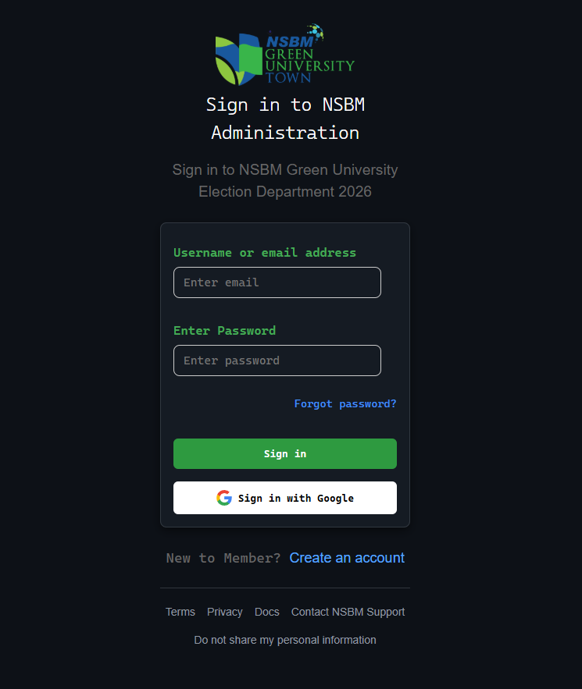These pages allow administrators to securely register and log in using their credentials. Only verified admins can access system management features, helping ensure the integrity of the election process.



### 8.2. Admin Dashboard

The Admin Dashboard provides an overview of the system’s key functionalities, including access to voter and candidate management, election controls, result monitoring, and system settings. It serves as the central hub for all administrative tasks.

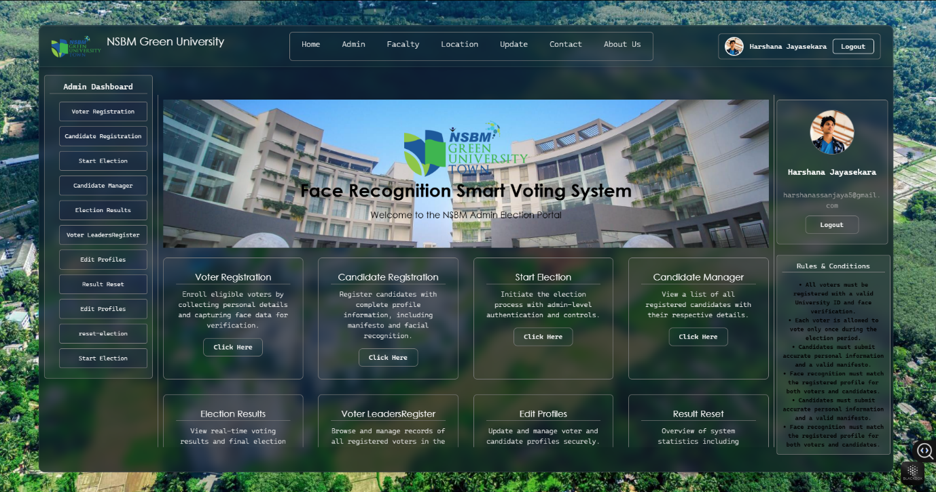

### 8.3. Voter Registration

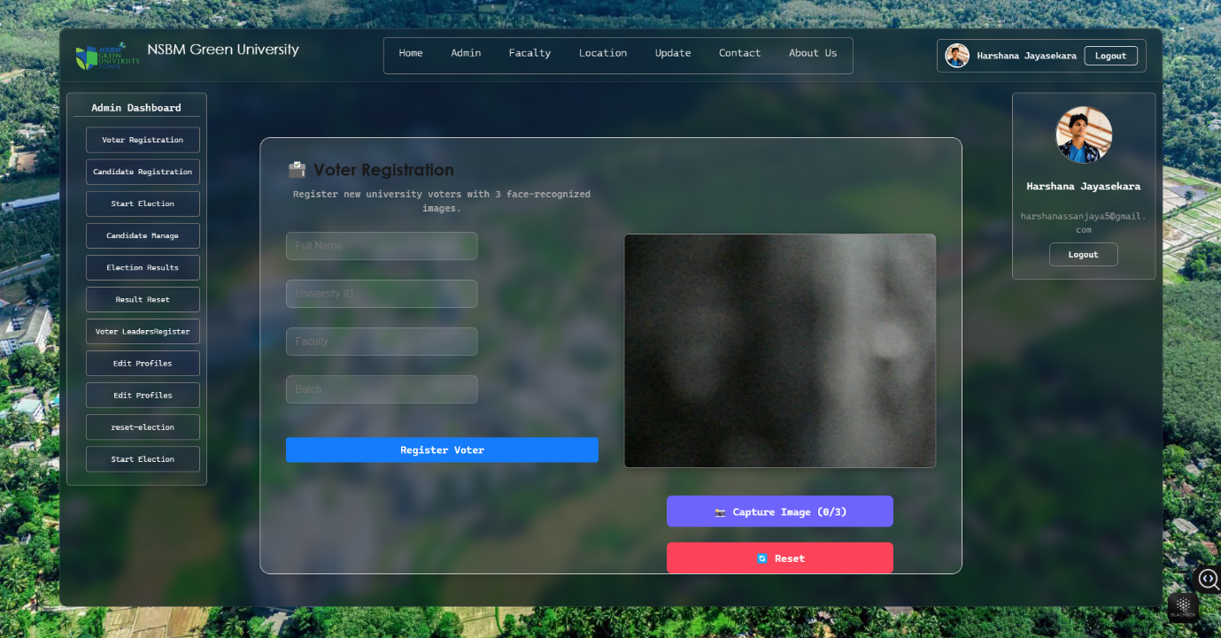This interface allows voters to register by submitting personal details (e.g., name, university ID, birthday) along with a real-time webcam image for facial recognition. All data is stored securely in Firebase for future authentication during voting.

### 8.4. Election Start page

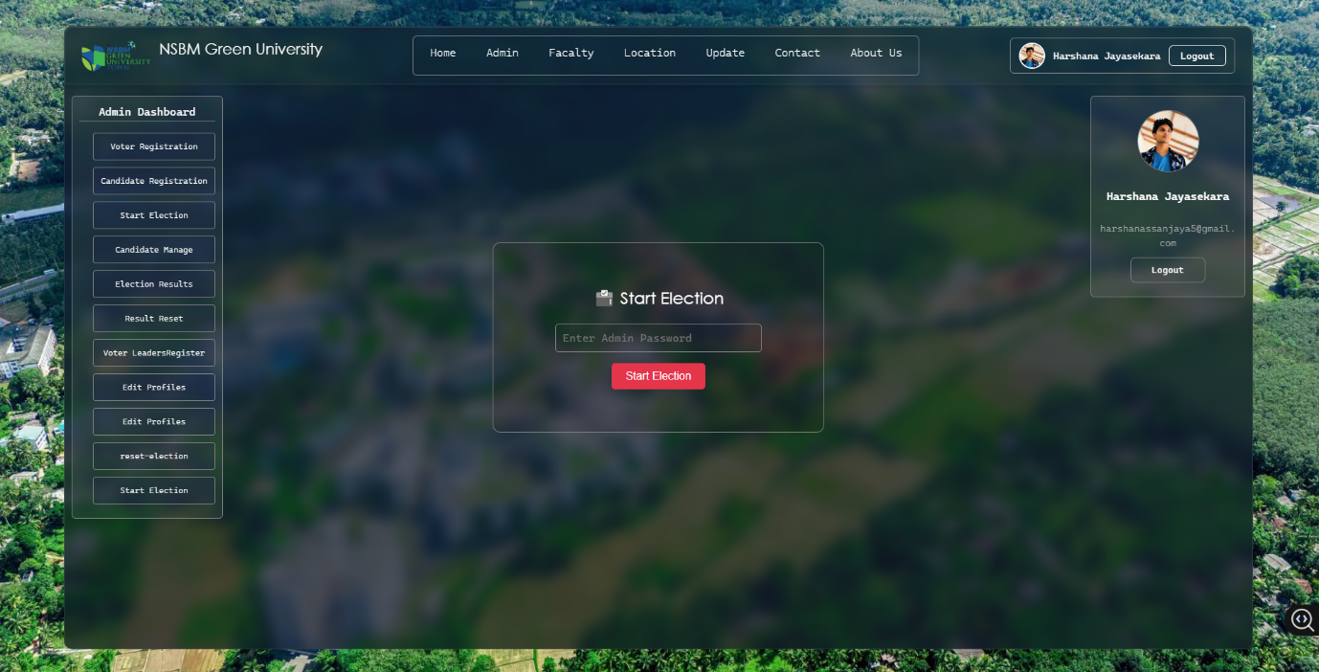 The Election Start page allows the admin to officially start the election after entering a secure password. Once started, the system enables voting access to registered users and disables registration or candidate modifications to maintain election integrity.

### 8.5. Candidate Manage page Edit and Deleted

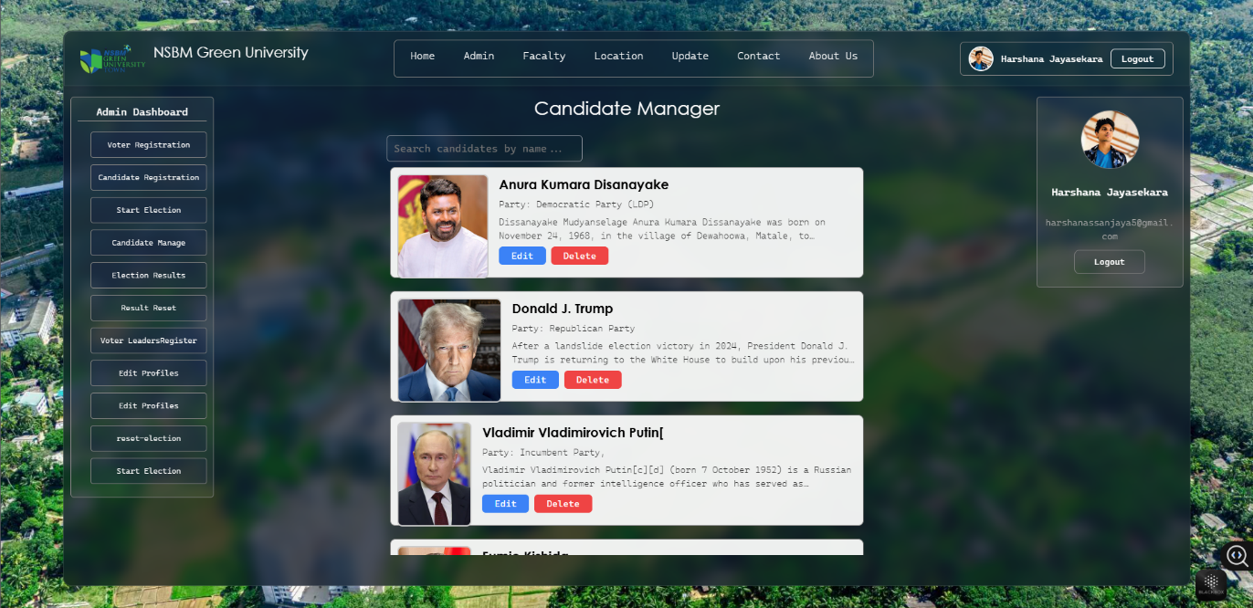This page allows the admin to add, edit, or delete candidate profiles. Admins can update candidate names, faculty, position, description, and profile images. Admin authentication is required for modifications to prevent unauthorized changes.

### 8.6 Election Result

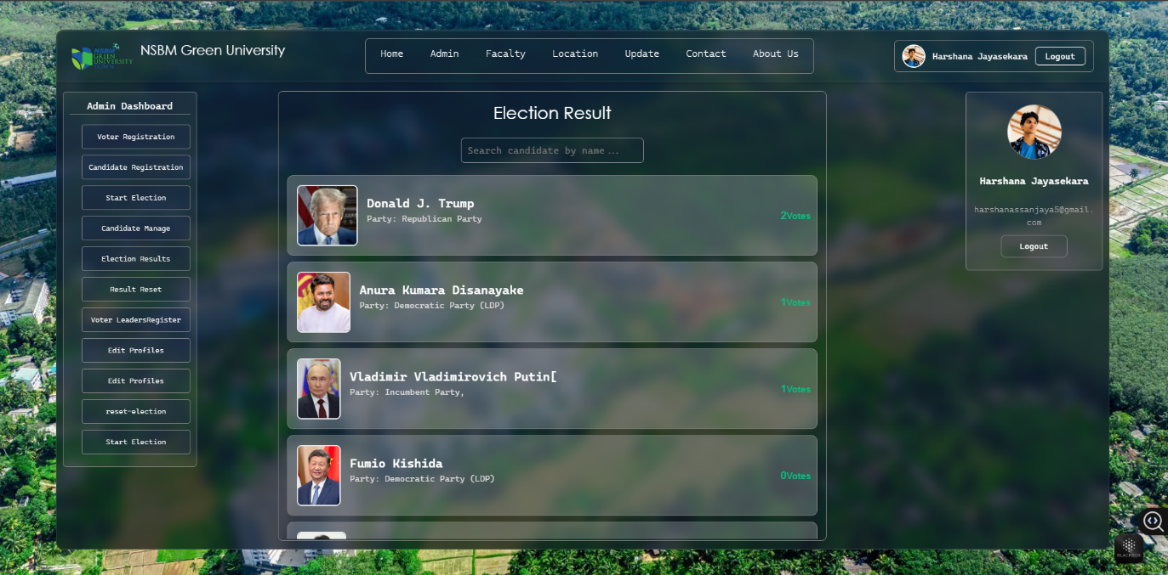The Election Result page displays real-time voting results, including the number of votes each candidate has received. Results are automatically updated based on votes cast and are only viewable after the election ends or by authorized admins during voting

### 8.7. Users Dashboard

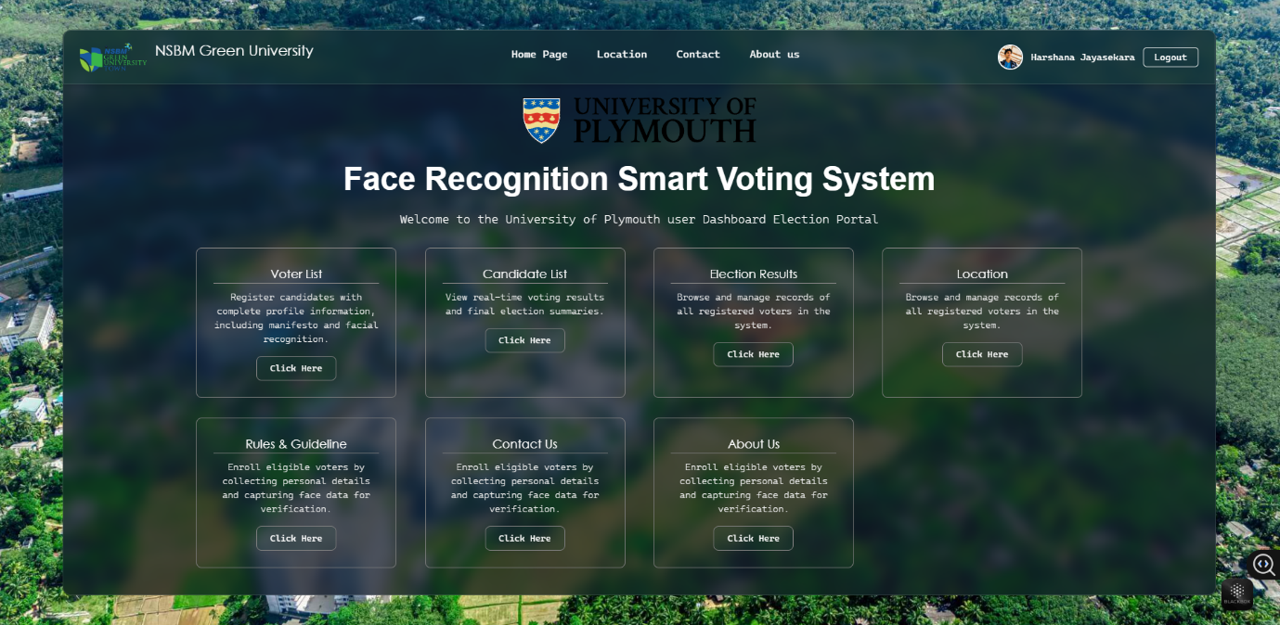The Users Dashboard is the interface for voters. It displays election instructions, personal voter information, and provides access to the voting page if the voter is eligible and has not yet voted. It enhances the user experience with clear navigation and status updates.

### 8.8. Map Location

This page displays a map view using integration with location services to show the university or election location. It can also be used to track voting booths or related physical locations, improving transparency and accessibility.



**PUSL3190 Computing Individual Project**

**Initiation Document**

**Smart Voting System using Face Detection and Recognition Application**

Supervisor

Ms. Kavishka Rajapaksha

Name: Harshana Jayasekara

Plymouth Index Number: 10899567

Degree Program: BSc. (Hons) Software Engineering

# Introduction

The Facial Recognition Voting System Web Application is a groundbreaking initiative designed to modernize and streamline the electoral process within a university setting. This project aims to harness the power of cutting-edge facial recognition technology to ensure secure, transparent, and efficient voting for university elections.

# Background

Elections are a fundamental part of democratic societies and provide a means for citizens to participate in their governance. Elections allow individuals to exercise their right to vote. They choose leaders who represent their interests and uphold democratic values.

In a democracy, every citizen has the right to vote for their choice. The main problems with the traditional democratic framework are the high cost of labor and resource consumption. The disadvantages of this election are that the traditional electoral system is a waste of labor, time, and resources. The disadvantages of this electoral system are that it requires a large amount of paper printing and a lot of paperwork. Also, voters living far from their place of birth have to travel to their native polling stations to cast their votes. Therefore, to overcome their shortcomings, a new method has been introduced, namely, an online voting system that provides accuracy, security, flexibility, mobility, etc. A web-based application or an online voting system using facial recognition has been identified as a suitable method to be used in the election process. It is an electronic voting machine that can easily store data and can be easily managed. It is more secure and less time-consuming than a ballot paper. A biometric authentication system has been proposed to make the voting process more secure and reduce the time taken in the voting process.

The voting system using facial recognition is a completely state-of-the-art and secure application designed to facilitate and improve the voting process. Face Recognition is a secure voting technology that ensures reliable, fast, and easy voting experience for voters. In a world where elections are a fundamental part of democracy, ensuring the integrity of the voting process is crucial. Traditional paper-based voting systems often face challenges related to fraud, identity verification, and accessibility. The Face Recognition web application harnesses the power of modern technology to do this.

# Relevance

The use of facial recognition technology has attracted widespread attention due to its ability to accurately and quickly verify individuals. Integrating this technology can significantly enhance the transparency and efficiency of the electoral process. This project can enable digital transformation and automation in various sectors, including education.

Intended impact

The project was inspired by the pressing need to address the inefficiencies and weaknesses of the traditional voting system. Several factors influenced the decision to pursue this initiative:

1. Observations of challenges in past university elections, such as long queues, mismanaged voter lists, and controversial results.
2. The success of facial recognition technology in other domains, including security and authentication, demonstrating its potential in electoral systems.
3. The desire to provide students with a modern, convenient, and reliable voting experience that reflects technological advancements in the wider world.

Expected Impact

The expected impact of the facial recognition voting system web application includes:

1. Enhanced Security: By eliminating the possibility of duplicate or fraudulent votes, the system will strengthen the integrity of university elections.
2. Improved Efficiency: Automating identity verification and vote counting will significantly reduce administrative burdens, saving time and resources.
3. Increased Voter Turnout: The convenience and user-friendliness of the system will encourage high participation rates among students.
4. Scalability and Adaptability: The project will serve as a model for other educational institutions looking to adopt similar methods, thereby contributing to a broader impact in the education sector.
5. Institutional Innovation: The implementation of this system will strengthen the university’s reputation as a forward-thinking institution embracing digital transformation.

# Business case

The Facial Recognition Voting System Web Application aims to address the critical challenges faced in university elections, providing a secure, efficient and transparent voting process. This section outlines the need for the project and defines its objectives, ensuring alignment with the broader objectives of university administration and governance.

## 2.1 Business needs

University elections are fundamental to fostering leadership, promoting democracy, and ensuring fair representation among the student body. However, existing methods for managing these elections often face significant challenges.

Traditional voting methods often face several issues that undermine their effectiveness and reliability in university elections. Key challenges include:

### Security issues:

* Manual verification processes are susceptible to human error and can be used to cast fraudulent votes.
* Duplicate voting or proxy voting compromises the integrity of election results.

Inefficiency:

* Manual management of voter records and verification of identities creates disruptions, long queues, and delays.
* Manual vote counting and reconciliation is time-consuming and increases the likelihood of errors.

Voter participation:

* Traditional methods often fail to engage tech-savvy students, resulting in low voter turnout.
* Lack of accessibility or convenience discourages eligible voters from participating.

Resource Consumption:

* Physical ballots and manual record keeping require significant resources, including paper, administrative staff, and time.

The facial recognition voting system can address these issues by providing a secure, automated, and user-friendly solution tailored to the needs of university elections. By integrating technology, the system ensures accurate voter identification, streamlines administrative processes, and increases accessibility for all eligible voters.

## 2.2 Supporting evidence

The necessity of this project is supported by:

Case Studies from Other Sectors:

* Biometric authentication, including facial recognition, has proven effective in industries such as banking and security, reducing fraud and increasing user satisfaction.

Survey Data:

* A university-conducted survey revealed that over 70% of students prefer digital solutions for administrative tasks, including voting.

Technological Trends:

* Studies predict a 15% annual growth in the adoption of facial recognition technology, highlighting its viability as a modern solution.

Environmental Benefits:

* Transitioning to a digital voting system eliminates the need for paper ballots, aligning with sustainability goals and reducing environmental impact.

## 2.3 Business objectives

The goals of this project align with the university’s mission to foster innovation, ensure fairness, and promote technological advancement.

### Specific business objectives include:

**Improve election security:**

* Ensure that only eligible voters participate by using facial recognition for identity verification.
* Eliminate duplicate and fraudulent voting practices.

**Streamline election processes:**

* Automate voter registration, verification, and results tabulation to reduce administrative overhead.
* Reduce the time it takes to conduct and manage elections.

**Increase voter turnout:**

* Encourage more students to participate in the election process by offering an accessible and user-friendly platform.

**Reduce costs**

* Reduce operational costs by eliminating paper ballots, reducing the need for physical polling stations, and minimizing human labor.

**Promote innovation and scalability:**

* Provide a scalable model for adoption by other universities or organizations.
* Demonstrate the institution as a leader in implementing cutting-edge technology for democratic processes.

**Improve trust and transparency:**

* Build trust among students, faculty, and stakeholders by ensuring the accuracy and integrity of election results.

# Project objectives

The Facial Recognition Voting System Web Application is designed to deliver specific, actionable results that directly contribute to improving the university election process. These objectives focus on what the project will achieve in terms of its deliverables, usability, and technical functionality. The objectives have been formulated using Bloom's Taxonomy to ensure clarity, accuracy, and attainability.

## 3.1 SMART objectives

Design a User-Centric Voting Interface

* Objective: Create an intuitive and accessible web application that allows students to vote without interruption.
* Outcome: Develop an interface that is easy to navigate for users of all technical proficiency levels, with a satisfaction rate exceeding 85% based on post-election surveys.

Implement secure facial recognition technology

* Objective: Develop and integrate a robust facial recognition system to accurately verify voter identities.
* Outcome: Achieve a facial recognition accuracy rate of 95% or higher, reducing the chances of identity fraud to near zero.

Ensure real-time vote processing and counting

* Objective: Enable real-time data handling for secure and efficient casting, storage, and counting of votes.
* Outcome: Deliver election results within 30 minutes of the close of voting, ensuring transparency and timeliness.

Voter accessibility and ease of entry

* Objective: Design the system to accommodate users with varying levels of access to technology and connectivity.
* Outcome: Ensure a functional voting process across devices with varying performance capabilities, including smartphones, tablets, and computers.

Develop a scalable and adaptable system architecture

* Objective: Create a modular system architecture that can be scaled for larger elections or adopted by other organizations.
* Outcome: Build a system with reusable components that can accommodate up to 10,000 voters with minimal modifications.

Perform robust testing and validation

* Objective: Conduct rigorous system testing to identify and address potential risks and biases.
* Outcome: Complete alpha and beta testing cycles, ensuring the system is 100% operational before deployment.

Promote sustainable practices

* Objective: Reduce resource consumption and environmental impact through digitization.
* Outcome: Complete elimination of paper-based voting materials, saving at least 5000 sheets of paper per election.

Educate stakeholders on the use of the system

* Objective: Provide training materials and sessions for voters and administrators.
* Outcome: Provide advisory guides and workshops with at least 90% of stakeholders reporting confidence in using the system.

# Literature review

A comprehensive review of the existing literature is crucial to understanding the theoretical basis of the web application of facial recognition voting. This section explores relevant studies, technologies, and use cases, identifying the gaps that this project aims to address.

## 4.1 Related work

Facial recognition technology has gained prominence in recent years, finding applications across multiple domains, including security, healthcare, and e-governance. Several studies and implementations demonstrate its effectiveness in improving operational

Facial Recognition in Authentication Systems:

Research on facial recognition technology highlights its effectiveness in secure authentication across a variety of domains, including banking, mobile devices, and surveillance. Studies highlight its high accuracy rates and ability to reduce fraud.

Key example:

* A study by Zhang et al. (2021) shows that deep learning-based facial recognition models achieve accuracy rates exceeding 98% in controlled environments.

Biometric systems in voting applications:

* Biometric systems, including fingerprints and facial recognition, have been deployed in pilot voting projects globally. These systems ensure voter identity verification, reducing the chances of impersonation.

Key example:

* The implementation of a biometric voting system in elections in Ghana significantly reduced duplicate registrations and fraudulent voting practices.

Limitations of traditional voting systems:

* Traditional voting systems, especially those that rely on manual processes, are prone to inefficiency, fraud, and human error. Studies also highlight issues related to cost and environmental impact.

Key example:

* An analysis by Anderson et al. (2019) found that manual vote counting resulted in margins of error of up to 3%, leading to disputes and delays in election results.

Challenges of biometric systems:

* Despite their advantages, biometric systems face challenges such as privacy concerns, potential bias, and technical limitations. Facial recognition technology, in particular, has been criticized for its low accuracy across diverse populations due to training dataset limitations.

Research gaps

Despite the successes of existing technologies, several gaps remain that this project aims to address:

**Limited adoption in educational institutions:**

* While facial recognition methods are prevalent in national elections, their adoption for university elections remains limited. Many systems rely on manual processes or outdated technologies that fail to meet the unique needs of academic settings.

**Cost and scalability challenges:**

* Many existing biometric systems are expensive and complex, making them unsuitable for small-scale elections like those at universities. This project aims to develop a cost-effective and scalable solution tailored for academic use.

**User experience and accessibility:**

* Some systems lack user-friendly interfaces, discouraging participation, especially among students who are unfamiliar with technology. The project prioritizes an intuitive and accessible design to maximize voter participation.

**Integrating real-time features:**

* Current systems often neglect real-time features such as live verification and instant results tabulation. Incorporating these features can streamline the election process and improve transparency.

**Data privacy issues:**

* Few systems adequately address the ethical and privacy issues associated with storing and processing facial data. This project will emphasize strong security protocols and compliance with privacy standards.

Conceptual diagram

* The following conceptual diagram outlines the high-level architecture and workflow of the proposed facial recognition voting system web application:

**User Registration:**

* Students register on the platform by submitting their details and uploading a photo for facial recognition.

**Voter Login:**

* On election day, users log in with their ID number and perform facial recognition for identity verification.

**Voting Process:**

* Once authenticated, voters access the voting interface, select their preferred candidates, and cast their votes.

**Result Calculation:**

* Votes are securely stored in a database, and the results are automatically calculated and displayed in real time.

**Administrator Dashboard:**

* Election officials monitor the process through a dashboard, monitoring verification rates, voter turnout, and live results.







# Approach method

The Facial Recognition Voting System Web Application will be developed using a structured approach that ensures efficiency, security, and usability. This section details the project methodology, tools, technologies, and frameworks to be utilized for its implementation.

## 5.1 Methodology

The project will follow the Agile Development Methodology, a flexible and iterative approach that ensures continuous progress, adaptation to changes, and efficient collaboration between stakeholders.

Key steps include:

**Requirements Collection:**

* Collect functional and non-functional requirements from stakeholders including students, university administration, and technical advisors.
* Define clear goals for the system based on the collected requirements.

**System Design:**

* Create wireframes and prototypes to visualize the user interface and system workflows.
* Prepare a high-level architectural diagram to outline the system components and their interactions.

**Incremental Development:**

* Divide the project into smaller modules, such as user registration, face recognition, voting, and result calculation.
* Implement and test each module to ensure quality and functionality.

**Testing and Validation:**

* Conduct unit tests, integration tests, and user acceptance tests to ensure system reliability and accuracy.
* Test the facial recognition system for a minimum accuracy rate of 95% under various conditions.

**Deployment:**

* Deploy the application on a secure server, ensuring accessibility and scalability.
* Provide user training sessions for students and administrators.

**Post-deployment maintenance:**

* Monitor system performance, address user feedback, and implement updates as needed

# Tools and technology

The development of the facial recognition voting system web application uses the following tools and technologies:

* **Front-end development:**
* React.js: To build a responsive and interactive user interface.
* Material-UI or: To design an intuitive and visually appealing layout.

**Back-end development:**

* Node.js: To handle server-side logic and API integration.
* Express.js: To build a RESTful API to manage communication between the front-end and back-end.

**Facial recognition:**

* OpenCV: To implement facial recognition algorithms and image processing.
* TensorFlow or Api: For advanced machine learning models if needed.

**Database:**

* Firebase Realtime Database: To store secure and real-time data, including user details and voting records.
* MySQL or PostgreSQL: As an option for structured data management.

**Hosting and deployment:**

* Firebase Hosting: To deploy web applications.
* AWS or Heroku: For scalable backend services.

**Testing tools:**

* Postman: For testing API endpoints.
* Jest: For front-end and back-end unit testing.

**Version control:**

* Git and GitHub: For version control and collaborative development.

**Security measures:**

* JWT (JSON Web Tokens): For secure authentication and session management.
* SSL/TLS: For encrypting communication between client and server.

## High-level architectural diagram

The high-level architecture of the system consists of the following components and interactions:

**User Interface Layer (Frontend):**

* Students and administrators interact with the system through a web application built using React.js.

**Application Logic Layer (Backend):**

* Handles user authentication, facial recognition processing, and voting operations using Node.js and Express.js.

**Face Recognition Engine:**

* Processes user-uploaded images and verifies identities using OpenCV and machine learning models.

**Database Layer:**

* Securely stores user data, election information, and voting records in a Firebase or alternative relational database.

**Security Layer:**

* protocols to protect data.

**Admin Dashboard:**

* Provides election officials with tools to track voter activity, manage candidates, and view real-time results.

# Basic project plan

A clear roadmap is crucial to ensure the successful completion of the Facial Recognition Voting System Web Application. This section presents a timeline with key milestones, tasks, deadlines, and assigned responsibilities. A Gantt chart visually represents the project timeline to provide an overview of progress.

## 6.1 Timeline

The development of the facial recognition voting system web application follows a structured timeline over a period of 16 weeks, ensuring that all key phases are completed on time.

**Week 1-2:**

* Requirements Analysis and Design
* Collect functional and non-functional requirements.
* Define the project scope, objectives, and deliverables.

Week 3-4:

* System Design
* Create wireframes, prototypes, and architectural diagrams.
* Finalize database design and application workflow.

Week 5-9:

* Development Phase
* Front-end Development: Build the user interface using React.js.
* Back-end Development: Implement server-side logic using Node.js and Express.js.
* Face Recognition Module: Integrate OpenCV for face recognition and user authentication.

Week 10-12:

* Testing Phase
* Conduct unit tests for each module.
* Perform integration and user acceptance testing to ensure functionality and reliability.

Week 13:

* Prepare for deployment
* Finalize the deployment strategy and set up the hosting environment.
* Conduct a pilot run with test users.

Week 14-15:

* Deployment and Training
* Deploy the application on a secure server.
* Train university staff and students on using the system.

Week 16:

* Post-deployment review and documentation
* Gather feedback from users.
* Finalize project documentation by resolving identified issues.

|  |  |  |  |
| --- | --- | --- | --- |
| Phase | Tasks | Start Date | End Date |
| 1. Project Initiation | Finalize requirements, gather resources, and outline the project scope. | Oct 10, 2024 | November 10, 2024 |
| 2. Research & Design | Conduct literature review, define architecture, and create wireframes. | November 10, 2024 | December 01, 2024 |
| 3. Development Phase 1 | Develop user interface and backend systems (voter registration module). | December 02, 2025 | January 12, 2025 |
| 4. Development Phase 2 | Integrate facial recognition technology and database configuration. | December 02, 2025 | January 12, 2025 |
| 5. Testing Phase | Perform functional, security, and user acceptance testing. | January 10, 2025 | February 01, 2025 |
| 6. Deployment | Deploy the application and train users and administrators. | January 15, 2024 | February 27, 2024 |
| 7. Post-Implementation | Monitor system, gather feedback, and perform final refinements. | February 28, 2025 | March 25, 2025 |

Timeline Link

<https://drive.google.com/drive/folders/1pmV5EuJlm_to-FN4zFheyKJclB6EK03C?usp=drive_link>

## 6.2 Gantt chart

The Gantt chart provides a visual representation of the project timeline, displaying tasks and their deadlines.



Gantt chart link <https://drive.google.com/drive/folders/1F7s2fF9_foJ1hjyKMgEIQsXVN1jfh-mF?usp=drive_link>

# Roles and Responsibilities

| Role | Responsibilities |
| --- | --- |

|  |  |
| --- | --- |
| Project Manager | Oversee the project, ensure milestones are met, and facilitate communication |
| Research Analyst | Conduct literature review and define system requirements. |
| UI/UX Design | Develop user-friendly and visually appealing application designs. |
| Frontend Developer | Create the web interface using React.js and ensure responsiveness |
| Backend Developer | Develop server-side logic and ensure integration with the database. |
| AI Specialist | Train and deploy facial recognition models using machine learning frameworks. |
| QA Check | Conduct rigorous testing to identify and fix bugs |
| Deployment | Deploy the application and ensure all components function as intended. |
| Maintenance | Monitor the system post-deployment and address feedback or issues |

## Roles and responsibilities

The project team is structured to ensure clear ownership of tasks, accountability, and efficient collaboration:

**Project Manager:**

* Oversee project timelines, resource allocation, and progress monitoring.
* Act as the primary liaison between stakeholders and the development team.

Front-end Developer:

* Design and implement the user interface of the web application using React.js.
* Ensure that the platform is user-friendly and responsive across devices.

Back-end Developer:

* Develop the server-side architecture using Node.js and Express.js.
* Implement APIs for communication between the front-end and the database.

Facial Recognition Specialist:

* Integrate and optimize the facial recognition module using OpenCV or similar tools.
* Ensure the accuracy and reliability of the biometric system.

Database Administrator:

* Design and maintain the database, ensuring data integrity and security.
* Implement measures to secure sensitive voter data.

Quality Assurance Tester:

* Conduct a thorough test of individual modules and the integrated system.
* Identify and resolve bugs or performance issues.

Deployment Specialist:

* Set up the hosting environment and ensure secure deployment.
* Handle system configurations and scalability.

Training and Support Coordinator:

* Train users (students and administrators) in using the platform.
* Provide ongoing technical support after deployment.

# Risk analysis

Effective risk management is crucial to the success of the Facial Recognition Voting System Web Application project. This section identifies potential risks, assesses their likelihood and impact, and outlines mitigation strategies to address them.

## 7.1 Identified risks

Technical Risks:

* System Downtime: Unexpected server failures can disrupt the application during critical election periods.
* Facial Recognition Errors: False positives or negatives during the identity verification process can lead to voter dissatisfaction or loss of trust.
* Integration Issues: Challenges in integrating the facial recognition module with the backend can delay the project.

Data Security Risks:

* Unauthorized Access: Malicious actors may attempt to breach the system to compromise voting data.
* Data Privacy Issues: Mishandling sensitive voter data can lead to privacy regulation violations.

Operational Risks:

* Low Voter Adoption: Resistance to adopting a new voting system, especially among non-tech-savvy users, can impact participation rates.
* Training Challenges: Inadequate training for administrators and students can lead to operational inefficiencies.

Resource Risks:

* Budget Overruns: Unexpected costs for tools or personnel can exceed the allocated budget.
* Team Availability: Limited availability of skilled developers or project staff can delay progress.

External Risks:

* Regulatory Compliance: Failure to meet data protection laws and election regulations can lead to legal challenges.
* Environmental Factors: Power outages or poor internet connectivity in some areas can disrupt voting.

# Stakeholder analysis

Stakeholder analysis identifies individuals, groups or organizations that can influence or be influenced by the facial recognition voting system web application. Understanding stakeholder needs, expectations, and impact levels is critical to ensuring project success.

## 8.1 Key stakeholders

### 1. Key stakeholders:

Students (voters):

* Role: Primary users of the system who vote in university elections.
* Interest: A secure, simple and efficient voting process with accurate results.
* Impact: High - Their adoption and satisfaction will determine the success of the system.
* Election Committee:
* Role: University officials oversee the election process and monitor the results.
* Interest: A reliable system for conducting elections in a transparent and efficient manner.
* Impact: High - Responsible for approving and monitoring the implementation of the system.

University Administration:

* Role: Sponsors of the project who provide financial and logistical support.
* Interest: Improving institutional reputation through innovative and secure processes.
* Impact: High - They allocate resources and evaluate project results.

### 2. Secondary Stakeholders:

IT Department:

* Role: Provides technical support including system integration, maintenance, and troubleshooting.
* Interest: Ensures the system is easy to maintain and is aligned with the university infrastructure.
* Impact: Medium - Their technical expertise ensures the stability of the system.

Project Development Team:

* Role: Developers, testers, and designers responsible for building the application.
* Interest: Delivers a successful, functional, and user-friendly product.
* Impact: High - Their performance directly impacts the project outcome.
* Faculty Members:
* Role: The system may be used for other purposes, such as faculty or department elections.
* Interest: A scalable system that can be adapted for widespread use.
* Impact: Low - Indirect users but potential advocates for the system.

### 3.External stakeholders:

Regulatory bodies:

* Role: Ensure that the voting system complies with electoral laws and data protection regulations.
* Interest: Legal compliance and adherence to ethical standards.
* Impact: Medium - Their approval is essential for the legitimacy of the system.
* Third-party vendors (tools and services):
* Role: Providers of technologies such as facial recognition software and hosting platforms.
* Interest: Provide reliable tools and services to improve system performance.
* Impact: Medium - Their tools affect the performance and scalability of the system.

| Stakeholder | Expectations | Management Strategy |
| --- | --- | --- |
| Students (Voters) | Secure, fast, and user-friendly voting experience. | Conduct usability testing and provide clear instructions and support. |
| Election Committee | Accurate and tamper-proof election results. | Regular progress updates, provide training, and involve them in system testing. |
| University Administration | Cost-effective and reputation-enhancing solution. | Present detailed financial and impact reports, emphasizing ROI and benefits. |
| IT Department | Easy integration with existing university infrastructure. | Involve them in the technical design phase and provide documentation. |
| Development Team | A clear project scope and realistic deadlines. | Use Agile practices for incremental progress and provide regular feedback. |
| Regulatory Bodies | Compliance with legal and ethical standards. | Engage legal advisors and document all compliance measures. |
| Third-Party Vendors | Proper implementation and usage of their tools. | Establish clear communication and service-level agreements (SLAs). |

# Stakeholder expectations and management

## Communication Plan

A robust communication plan is implemented to ensure all stakeholders are informed and aligned with project goals:

* Weekly Updates: Progress reports sent to the Election Committee and University Administration.
* Monthly Reviews: In-person or virtual meetings with primary stakeholders to review milestones and resolve issues.
* Feedback Mechanisms: Regular surveys and user feedback sessions with students and faculty.
* Technical Documentation: Detailed manuals for the IT department and administrators for system maintenance.
* Training Sessions: Workshops to familiarize students and administrators with the system.
* Ethical considerations

## 9.1 Privacy and Data Protection

Collection of Biometric Data:

* Ethical Concern: Facial recognition technology requires the collection and storage of sensitive biometric data, which raises privacy concerns.
* Mitigation:
* Collect only the data necessary for voter identification.
* Anonymize stored data to prevent misuse or unauthorized identification.
* Adhere to relevant data protection regulations, such as GDPR, ensuring compliance with legal standards.

Informed Consent:

* Ethical Concern: Users must fully understand how their biometric data will be used, stored, and protected.
* Mitigation:
* Provide clear, user-friendly consent forms before data collection.
* Offer an alternative voting method for individuals uncomfortable with facial recognition technology.

## 9.2 Security and Confidentiality

System Vulnerabilities:

Ethical Concern: A breach in the system could expose sensitive voter data or election results.

Mitigation:

* Implement robust encryption and multi-layered security protocols.
* Conduct regular security audits to identify and address vulnerabilities.

Administrator Access:

Ethical Concern: Excessive privileges for administrators could lead to misuse or tampering.

Mitigation:

* Restrict access to sensitive data to authorized personnel only.
* Maintain a detailed activity log for transparency and accountability.

## 9.3 Fairness and Non-Discrimination

Bias in Facial Recognition:

* Ethical Concern: Facial recognition systems can sometimes exhibit bias against certain demographics, such as skin tone, age, or gender.

Mitigation:

* Use diverse training datasets to improve system accuracy across demographics.
* Regularly test the system to ensure it performs equitably for all users.

Equal Access:

* Ethical Concern: Some students may lack access to the necessary technology (e.g., smartphones or internet).

Mitigation:

* Provide public access points with devices to ensure every eligible voter can participate.
* Include alternative mechanisms for voting to accommodate all users.

## 9.4 Transparency and Accountability

1. Tamper-Proof Elections:

Ethical Concern: Ensuring the election process is transparent and results are credible.

Mitigation:

* Publish anonymized and verifiable election data to allow independent verification.
* Use blockchain or similar tamper-proof technologies for recording votes.

2.Stakeholder Trust:

Ethical Concern: Lack of transparency may lead to mistrust among students and administrators.

Mitigation:

* Involve key stakeholders in the testing and validation phases.
* Clearly communicate the system’s functionality and safeguards to all users.

## 9.5 Ethical Use of Technology

Scope of Use:

* Ethical Concern: The facial recognition data collected for voting purposes could potentially be misused for other purposes, such as surveillance.

Mitigation:

* Legally bind the university to use the data exclusively for elections.
* Establish strict policies for data retention and deletion after the election period.

Sustainability:

* Ethical Concern: Ensuring the technology used is not only ethical but also sustainable in the long term.

Mitigation:

* Choose energy-efficient algorithms and systems to minimize environmental impact.
* Promote sustainable practices in the design, deployment, and maintenance of the application.

# References

1. *Najam, S.S., Shaikh, A.Z. and Naqvi, S., 2018. A novel hybrid biometric electronic voting system: Integrating finger print and face recognition. Mehran University Research Journal of Engineering & Technology, 37(1), pp.59-68.*
2. *Parmar, A., Gada, S., Loke, T., Jain, Y., Pathak, S. and Patil, S., 2021, July. Secure E-Voting System using Blockchain technology and authentication via Face recognition and Mobile OTP. In 2021 12th International Conference on Computing Communication and Networking Technologies (ICCCNT) (pp. 1-5). IEEE.*
3. *Mandavkar, A.A. and Agawane, R.V., 2015, June. Mobile based facial recognition using otp verification for voting system. In 2015 IEEE International advance computing conference (IACC) (pp. 644-649). IEEE.*
4. *Malwade, N., Tavare, M., Kamble, A. and Kakrambe, A., Smart Voting System with Face Recognition. BEST: International Journal of Management, Information Technology and Engineering (BEST: IJMITE), 2(2), pp.31-38.*
5. *Sulaiman, M.M.K.M.M., Othman, M.F.I., Shah, W.M., Hassan, A., Harum, N. and Alseadoon, I.M., 2021. An Online Voting System using Face Recognition for Campus Election. Journal of Advanced Computing Technology and Application (JACTA), 3(1), pp.37-42.*
6. *Gupta, S., Jain, D. and Themalil, M.T., 2021, April. Electronic Voting Mechanism using Microcontroller ATmega328P with Face Recognition. In 2021 5th International Conference on Computing Methodologies and Communication (ICCMC) (pp. 1471-1476). IEEE.*
7. *Alim, M.A., Baig, M.M., Mehboob, S. and Naseem, I., 2017, June. Method for secure electronic voting system: face recognition based approach. In Second international workshop on pattern recognition (Vol. 10443, pp. 76-80). SPIE.*
8. *Abd Hamid, N., Appunair, C.D.N., Abidin, A.F.A., Mohamed, M.A., Kadir, M.F.A. and Satar, S.D.M., 2023. A SECURE ONLINE VOTING SYSTEM USING FACE RECOGNITION TECHNOLOGY. Malaysian Journal of Computing and Applied Mathematics, 6(1), pp.1-*
9. *Sebi, A., Biju, B., Joy K, G. and Shalini, K.S., 2023, January. Smart voting system using face recognition and fingerprint module. In AIP Conference Proceedings (Vol. 2523, No. 1). AIP Publishing.*
10. *Hegde, Ganapatikrishna P., and M. Seetha. "Real Time Voting System Using Face Recognition for Different Expressions and Pose Variations." IJRET: International Journal of Research in Engineering and Technology: 2319-1163*



**PUSL3190 Computing Individual Project**

**Interim Report**

**Smart Voting System using Face Detection and Recognition Application**

Supervisor

Ms. Kavishka Rajapaksha

Name: Harshana Jayasekara

Plymouth Index Number: 10899567

Degree Program: BSc. (Hons) Software Engineering

Table of Contents

Chapter 01: Introduction 3

1.1 Introduction 3

1.2 Problem Definition 3

1.3 Project Objectives 3

Chapter 02: System Analysis 4

2.1 Data Collection Techniques 4

2.2 Existing System 5

2.4 Shortcomings of the Current System 6

Chapter 03: Requirements Specification 7

3.1 Functional Requirements 7

3.2 Non-functional requirements 8

3.3 Hardware / Software Requirements 8

3.4 Networking Requirements (Optional) 9

Chapter 04: Feasibility Study 9

4.1 Operational Feasibility 9

4.2 Technical Feasibility 10

4.3 Outline Budget 11

Chapter 05: System Architecture 12

5.1 Class Diagram of the Proposed System 12

5.2 ER Diagram 13

5.3 High-level Architectural Diagram 14

5.4 Networking Diagram 15

Chapter 06: Development Tools and Technologies 15

6.1 Development Methodology 15

Programming Languages ​​and Tools 16

Third-party components and libraries 16

6.4 Algorithms 17

Chapter 07: Discussion 17

7.1 Overview of the Interim Report 17

7.2 Report Summary 17

7.3 Challenges Faced 18

7.4 Future Plans / Upcoming Work 18

References 19

Appendices (if applicable) 20

## Chapter 01: Introduction

### 1.1 Introduction

Rapid advancement in technology has led to digital transformation in various sectors including voting systems. Traditional voting systems such as paper-based ballots and electronic voting machines often face challenges related to security, accessibility, and efficiency. Facial recognition technology offers a modern and secure solution to address these issues by ensuring voter authentication and minimizing electoral fraud.

This project focuses on developing a facial recognition voting system designed for university elections. The system uses artificial intelligence and biometric authentication to verify voter identity, prevent multiple votes, and prevent unauthorized access. The system aims to streamline the voting process by integrating a secure and user-friendly interface while maintaining transparency and accuracy.

### 1.2 Problem Definition

Traditional voting methods in universities often involve manual processes, leading to inefficiencies, security issues, and potential fraud. Some of the key challenges faced by the current system include:

* Identity Fraud: Traditional student ID-based voting can be manipulated through fake or borrowed IDs.
* Time-consuming process: Manual verification and paper-based voting methods slow down the election process.
* Limited accessibility: Students may face difficulties in physically reaching polling stations, which reduces voter turnout.
* Counting errors: Manual vote counting increases the risk of human error and delays in results.

To address these issues, a facial recognition voting system is proposed, ensuring secure authentication, faster processing, and improved voter participation.

### 1.3 Project Objectives

The primary objectives of this project are:

1. To develop a secure facial recognition-based voting system for voter authentication using biometric data.
2. To enhance election security by preventing fraudulent activities such as multiple voting and impersonation.
3. To improve voting efficiency by reducing the time required for voter authentication and vote counting.
4. To increase voter accessibility by allowing students to vote through a digital platform.
5. To ensure system reliability and scalability by implementing robust backend architecture and data security measures.
6. To provide real-time election monitoring and reporting for administrators and election officials.

The project aims to contribute to a more secure, efficient and transparent election process in a university setting, utilizing modern biometric authentication techniques.

## Chapter 02: System Analysis

### 2.1 Data Collection Techniques

To design and develop an effective facial recognition voting system, various data collection techniques were used to collect relevant information about the existing voting systems, their limitations, and user needs. The main techniques used include:

1. Surveys and Questionnaires

* Surveys were conducted among students, faculty members, and election committee members to gather an understanding of the challenges faced by the current voting system.
* Feedback was collected regarding security issues, accessibility, and user experience.

2. Interviews

* Discussions were held with university election officials to understand the current voting process, authentication methods, and security measures.
* Interviews were conducted with IT staff to assess the feasibility of integrating facial recognition technology into the university’s infrastructure.

3. Observation

* The voting process was observed in previous university elections to identify inefficiencies and potential areas for improvement.
* Common issues such as long queues, identity verification delays, and human error in vote counting were noted.

4. Literature Review

* Analyzed academic papers and case studies on biometric voting systems, electronic voting security, and facial recognition technology to understand industry best practices.

5. Document Analysis

* Official university election guidelines and past election reports were reviewed to identify procedural hurdles and security risks.

### 2.2 Existing System

The current university election process relies primarily on a manual voting system with the following key features:

1. Voter Registration: Students register to vote using university-issued ID cards.
2. Manual Verification: Election officials manually verify the identity of each voter using ID cards and student records.
3. Paper-based or electronic voting: Voting is done on ballots or through a basic electronic voting system.
4. Vote counting: Election officials manually count the votes, which can lead to delays and potential human errors.
5. Results announcement: Results are compiled and announced after verification.

Security measures in the existing system:

* Verification of student ID cards by election officials.
* Signature verification to confirm the vote.
* Access to vote counting areas is restricted.

**2.3 Use Case Diagram**

A case diagram depicts the interaction between users (actors) and system functionalities. A text description of the use case diagram for the facial recognition voting system is given below:

Actors:

* Voter (student): Registers in the system, verify identity using facial recognition, and casts a vote.
* Election Administrator: Manages the election process, verifies system security, and monitors voting sessions.
* System Database: Stores voter data, facial recognition records, and election results.

Key Use Cases:

1. User Registration - The system registers students' facial data for verification.
2. Facial Verification - The system verifies the voter's identity before allowing them to vote.
3. Voting - The student selects a candidate and casts their vote.
4. Results Compilation - The system counts and stores the votes securely.
5. Election Monitoring - Administrators monitor the voting process in real time.
6. (A visual representation of the use case diagram should be included here.)

### 2.4 Shortcomings of the Current System

The current voting system has several limitations that affect the integrity, security, and efficiency of elections. These disadvantages include:

1. Security Issues

* Identity Fraud: Students can use fake or borrowed ID cards to vote on behalf of others.
* Multiple Voting: Some students can use loopholes to vote more than once.
* Translation Risks: Paper ballots and electronic voting machines are susceptible to tampering.

2. Inefficiency

* Slow Verification Process: Manual ID checks and paper-based registration slow down the voting process.
* Delayed Vote Counting: Manual counting is time-consuming and can lead to errors.
* Long queues: Due to slow verification, students experience long waiting times to cast their ballots.

3. Accessibility issues

* Limited voting locations: Students must be physically present at designated polling stations, which reduces voter turnout.
* Scheduling conflicts: Some students may not be able to vote due to class schedules or other commitments.

4. Human error

* Incorrect vote counting: Manual vote counting increases the risk of errors.
* Data loss: In the case of misplaced or damaged ballots, vote integrity is at risk.

Need for a new system

To overcome these limitations, the facial recognition voting system is designed to:

✔ Secure and fraud-resistant authentication

✔ Fast and automated vote counting

✔ Remote accessibility for eligible voters

✔ Eliminate human error in vote verification and compilation of

## Chapter 03: Requirements Specification

### 3.1 Functional Requirements

Functional requirements define the essential features and operations that a facial recognition voting system must support.

User Authentication and Registration:

* The system allow students to register using their student ID card and facial biometric data.
* The system shall verify a voter’s identity using facial recognition technology before granting access to vote.

Voting Process:

* The system shall allow registered users to vote securely.
* Each voter shall be permitted to vote only once per election cycle.
* The system shall encrypt all votes and store them in a secure tamper-proof database.

Election Management:

* The system shall allow election administrators to manage elections, including setting up candidates and voter qualifications.
* Administrators will be able to monitor real-time voting statistics.
* The system will automatically close voting after the specified time.

Result compilation and reporting:

* The system will automatically count votes and generate results without manual intervention.
* Election results will be displayed in a secure and transparent manner.
* The system will generate audit logs to monitor all voting activities.

Security features:

* The system should ensure two-factor authentication for administrators.
* There should be live detection of facial recognition to prevent fraudulent attacks (e.g. using photos or videos).
* Only authorized people have access to change system settings.



### 3.2 Non-functional requirements

* Non-functional requirements that define the quality attributes of the system, system performance, and aspects of usability.

Security and Privacy:

* The system should store facial biometric data in encrypted format to ensure data confidentiality.
* Only authenticated and authorized users should access the system.

Performance and Efficiency:

* The system should verify a voter’s identity in less than 2 seconds.
* The system should support at least 1000 concurrent users during peak voting hours.
* The vote counting should be fully automated with results generated in real-time.

Scalability and Maintainability:

* The system should be scalable to accommodate larger elections in the future.
* The architecture should allow for easy updates and maintenance without disrupting elections.

Usage and Accessibility:

* The user interface should be simple and intuitive for students to navigate.
* The system can be accessed across multiple devices (computers, tablets, mobile phones).

### 3.3 Hardware / Software Requirements

#### Hardware Requirements:

|  |  |
| --- | --- |
| Component | Minimum Requirements |
| Server | Intel Xeon 8-core processor, 8GB RAM, 1TB SSD |
| Workstations | Intel i5, 4GB RAM, 256GB SSD |
| Camera for facial recognition | 1080p HD camera with infrared support |
| Database Server | 100GB SSD, backup storage |
| Network device | router with secure VPN, firewall |
| Mobile devices (optional | Android/iOS smartphone with front camera |

#### Software Requirements:

|  |  |
| --- | --- |
| Software Component | Description |
| Operating System | Windows Server |
| Database | MySQL |
| Backend | Node.js |
| Frontend | React.js |
| Facial Recognition API | OpenCV |
| Cloud Storage (optional) | Firebase |
| Security Framework | WT Authentication, SSL Encryption |

### 3.4 Networking Requirements (Optional)

* High-speed Internet connectivity to ensure seamless authentication and vote submission.
* Secure VPN connection for election administrators to access system dashboards.
* Implementation of firewalls and intrusion detection systems to prevent cyber threats.

## Chapter 04: Feasibility Study

### 4.1 Operational Feasibility

Operational feasibility evaluates how well the proposed facial recognition voting system fits into the university’s electoral process and whether users (students, election officials, and administrators) can effectively follow it.

#### Key Considerations:

User Adoption:

* The system provides an intuitive interface, making it easy for students to vote.
* One-time facial registration ensures a seamless voting experience for future elections.

Security and Reliability:

* Eliminates the risk of identity fraud, multiple voting, and voter abuse.
* Ensures election transparency, increasing trust in the voting process.

Efficiency and Time Saving:

* Reduces long queues and delays in voting.
* Automated verification and vote counting streamline the entire election process.

Integration with existing infrastructure:

* The system can integrate with the university’s existing student database for authentication.
* Minimal training is required for election officials to manage the system.

### 4.2 Technical Feasibility

Technical feasibility assesses whether the university has the necessary hardware, software, and expertise to implement the system.

1. Hardware and Infrastructure:

* High-resolution cameras are required for accurate face recognition.
* Servers with sufficient processing power are required to handle concurrent user requests.
* Cloud or on-premises storage for storing secure biometric data.

2. Software and Development:

* Developed using React.js (frontend) and Node.js (backend) for scalability and performance.
* Uses OpenCV, AWS Recognition, or TensorFlow for facial recognition.
* Database solutions such as MySQL/PostgreSQL ensure secure data management.

3. Network and Security:

* A high-speed network connection is required for real-time authentication.
* Implementation of SSL encryption, firewall, and intrusion detection to protect against cyber threats.

4. Development Team and Expertise:

* The project team is proficient in React, Node.js, database management, and biometric technology.
* The system requires periodic maintenance, which can be handled by the university's IT department.



### 4.3 Outline Budget

The budget outlines the estimated costs for hardware, software, development, and maintenance.

|  |  |
| --- | --- |
| Category | Estimated Cost (USD) |
| Hardware Components | 120$ |
| High-definition cameras | 40$ |
| Server with 16GB RAM, 1TB SSD | 55$ |
| Secure network setup (firewall, VPN) | 5$ |
| Software and development | 5$ |
| Open-source facial recognition API | 14$ |
| Web hosting and cloud storage | 20$ |
| Database license | 0$ |
| Web hosting and cloud storage | 5$ |
| Database license | 16$ |
| Development and testing | 0$ |
| Security and maintenance | 0$ |
| SSL certificate |  |
| Cybersecurity tools | 0$ |
| System maintenance and updates | 0$ |
| Total estimated budget | 450$ |

## Chapter 05: System Architecture

### 5.1 Class Diagram of the Proposed System

The class diagram depicts the main objects of the system, their properties, methods, and relationships.

#### Main classes:

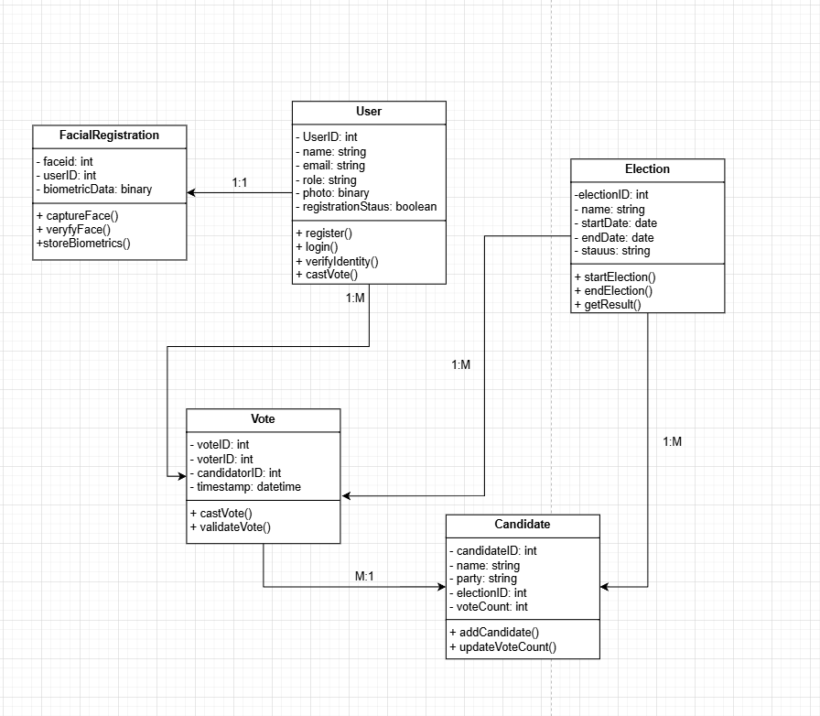<https://drive.google.com/file/d/1FdvlENfwN1jp1uBvgTTiN3WPlfPRuzGw/view?usp=sharing>

**User (Voter and Admin)**

* Attributes: UserID, Name, Email, Role, Photo, Registration Status
* Methods: register(), login(), verifyIdentity(), castVote()

**Election**

* Attributes: electionID, Name, startDate, endDate, status
* Methods: startElection(), endElection(), getResults()

**Candidate**

* Attributes: candidateID, Name, Party, electionID, voteCount
* Methods: addCandidate(), updateVoteCount()

**Vote**

* Attributes: voteID, voterID, candidateID, timestamp
* Methods: castVote(), validateVote()

**Facial Recognition**

* Attributes: faceID, userID, biometricData
* Methods: captureFace(), verifyFace(), storeBiometricData()

### 5.2 ER Diagram

The Entity-Relationship (ER) diagram represents the database structure, showing entities, attributes, and relationships.

[https://drive.google.com/file/d/1jK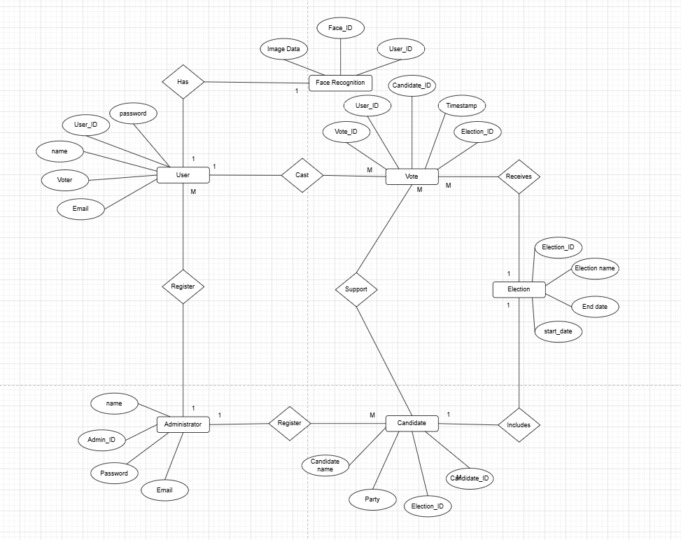ZoxWXAPHMioMynVZmBNlWgoXz0giTA/view?usp=sharing](https://drive.google.com/file/d/1jKZoxWXAPHMioMynVZmBNlWgoXz0giTA/view?usp=sharing)

Key entities and relationships:

1. Administrator

**Administrator(Admin_ID, Name, Email, Password)**

* Admin_ID (Primary Key)

1. User

**User(User_ID, Name, Role, Email, Password, Registered_By)**

* User_ID (Primary Key)
* Role (Voter or Administrator)
* Registered_By (Foreign Key Referral Administrator)

1. Candidate

**Candidate(Candidate_ID, Candidate_Name, Party, Election_ID, Registered_By)**

* Candidate_ID (Primary key)
* Election_ID (Foreign_Key Referring Election)
* Registered_By (Foreign_Key Referring Administrator)

1. Vote

**Vote(Vote_ID, User_ID, Candidate_ID, Election_ID, Timestamp)**

* Vote_ID (Primary Key)
* User_ID (Foreign_Key Referring User)
* Candidate_ID (Candidate_ID)
* Election_ID (Foreign_Key Referring Election)

1. Face Recognition

**Face_Recognition(Face_ID, User_ID, Image_Data)**

* Face_ID (Primary key)
* user_id (the user that the foreign key refers to)

1. Election

**election(election_id, election_name, start_date, end_date)**

* election_id (primary key)

### 5.3 High-level Architectural Diagram

The high-level architecture of the system follows a 3-tier architecture:

1. Presentation Layer (Front-end) - React.js

* Provides the user interface for voters and administrators.
* Handles facial recognition input using a webcam or mobile camera.

2. Application Layer (Back-end) - Node.js with Express.js

* Manages user authentication, facial recognition processing, and vote handling.
* Securely processes and encrypts voting transactions.

3. Data Layer (Database) - MySQL/PostgreSQL

* Stores user data, election details, votes, and facial recognition data.
* Ensures data integrity and real-time updates.

### 5.4 Networking Diagram

If applicable, the networking diagram should depict:

* How users (voters and administrators) interact with the system via web and mobile.
* Secure VPN connections for election officials to access results.
* Firewalls and encryption layers that protect the database and facial recognition data.

## Chapter 06: Development Tools and Technologies

### 6.1 Development Methodology

The development of the facial recognition voting system follows the agile methodology, specifically the Scrum framework.

***Why Agile?***

* Iterative Development: The system is developed in multiple sprints, allowing for incremental improvements.
* Continuous Feedback: Testing and validation are performed after each sprint to refine functionality.
* Flexibility: New requirements or changes can be incorporated efficiently.

***Development Phases:***

1. Requirements Gathering and Planning - Define user requirements, use cases, and technical specifications.
2. System Design - Develop architectural diagrams, database schemas, and UI wireframes.
3. Implementation and Development - Code the front-end, back-end, and integrate facial recognition.
4. Testing and Validation - Conduct behavioral unit, integration, and security testing.

### Programming Languages ​​and Tools

The system is developed using modern web and AI-based technologies for scalability and security.

|  |  |  |
| --- | --- | --- |
| Component | Technology Used | Reason |
| Frontend | React.js | Fast, scalable and component-based UI development. |
| Backend | Node.js | Efficient API handling and real-time data processing. |
| Database | MySQL | Secure relational database for structured voting data. |
| Facial Recognition | OpenCV | AI-based face authentication. |
| Authentication | JWT | Secure user login and session management. |
| Hosting | Firebase | Scalable cloud-based hosting. |

### Third-party components and libraries

Several third-party libraries and APIs are integrated to improve the performance and security of the system.

|  |  |  |
| --- | --- | --- |
| Component | Library / API | Purpose |
| Face Recognition | OpenCV, AWS Re-Recognition | Face Recognition and Authentication. |
| User Authentication | Passport.js / Firebase Auth | Secure User Login. |
| Frontend UI | Material-UI | Modern and Responsive UI Components. |
| Database Management | Serialization (ORM) | Simplifies Database Queries. |
| Data Encryption | bcrypt.js | Secure Password Storage. |
| Real-Time Updates | Firebase Firestore | Ensure Live Vote Updates. |

### Algorithms

Various algorithms are used to improve the security and efficiency of the voting system.

1. Face Recognition Algorithms (Deep Learning and AI-Based)

* Uses Convolutional Neural Networks (CNNs) for accurate face recognition.
* Ensures liveness detection to prevent spoofing attacks (e.g. using printed photos).

2. Secure Voting Algorithm

* Uses a one-vote-per-user mechanism to prevent duplicate voting.
* Encrypts vote using AES-256 before storing them in the database.

3. Data Integrity and Authentication Algorithm

* Implements SHA-256 hashing to ensure that voting records cannot be altered.
* Verifying vote authenticity before processing results.

## Chapter 07: Discussion

### 7.1 Overview of the Interim Report

This interim report presents the progress of the facial recognition voting system for university elections. The report describes the system design, development methodology, feasibility studies, technical specifications, and architectural components. By integrating facial recognition technology, the system ensures a secure, efficient, and fraud-free voting process.

The document covers:

* Introduction and Problem Statement - Identifies the need for a digital voting system.
* System Analysis - Evaluates the existing voting process and its shortcomings.
* Requirements Specification - Lists functional and non-functional system requirements.
* Feasibility Study - Assesses operational, technical, and financial feasibility.
* System Architecture - Outlines the high-level system design and components.
* Development Tools and Technologies - Describes the programming languages, frameworks, and AI models used.

### 7.2 Report Summary

The facial recognition voting system is designed to modernize university elections by replacing traditional voting methods with a biometric-based online system. Key features include:

* Facial verification - Eliminates voter impersonation.
* Automated vote counting - Increases efficiency and accuracy.
* Secure and transparent process - Uses encryption and access control measures.

The system uses React.js (frontend), Node.js (backend), MySQL/PostgreSQL (database), and OpenCV/TensorFlow (facial recognition) to provide a robust voting solution.

### 7.3 Challenges Faced

While developing the system, several challenges were encountered:

1. Facial Recognition Accuracy

* Ensure high accuracy of recognition even in low light conditions or with minor facial variations.
* Solution: Train AI models with different datasets for improved recognition.

2. Fraudulent Attack Prevention

* Photo/Video-based attack vulnerability.
* Solution: Implement liveness detection and anti-spoofing techniques.

3. Data Security and Privacy

* Securely store biometric data in accordance with data protection policies.
* Solution: Encrypt facial data using AES-256 encryption and secure transmission with SSL/TLS protocols. BN

4. Integration with University Systems

* Ensure compatibility with existing student databases.
* Solution: Implement API-based data synchronization.

### 7.4 Future Plans / Upcoming Work

Upcoming tasks include:

* System testing and refinement - Conduct usability testing with students and election officials.
* AI model performance enhancement - Improve recognition speed and accuracy.
* Deployment and security enhancements - Strengthen security measures before deployment.
* User training and documentation - Develop a user guide for administrators and voters.



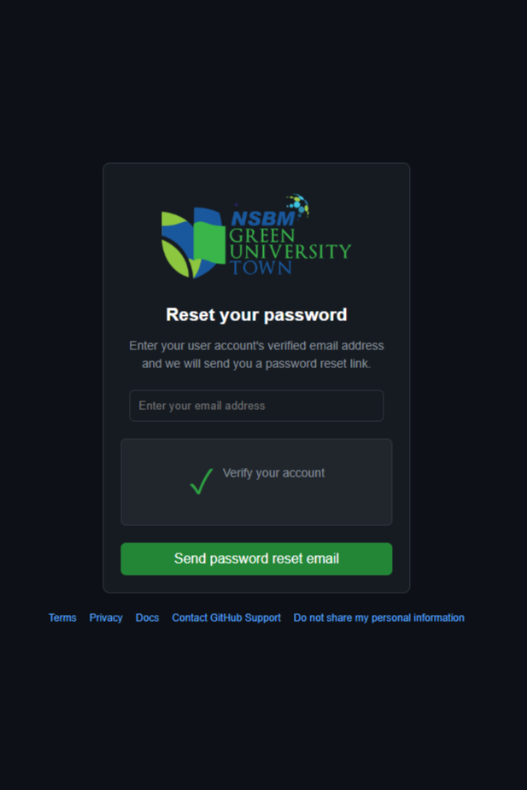

## Appendices (if applicable)

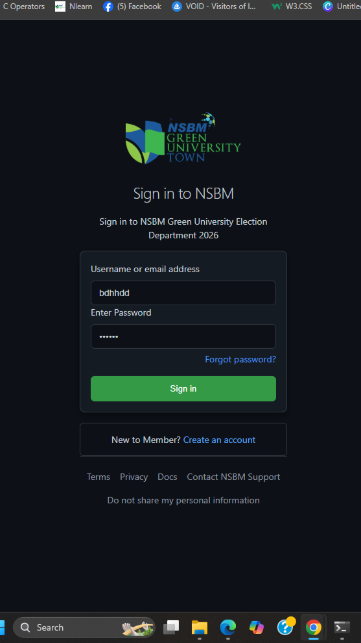

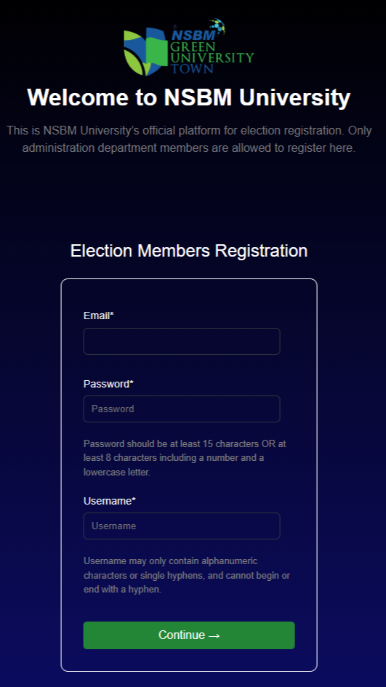



Thank You

